PROJECT REPORT
on
CampusCare : A centralized campus utility & Support web Application
Submitted by

Mr. Vedant Milind Pomendkar

in partial fulfilment for the award of the degree
of

BACHELOR OF SCIENCE
in

COMPUTER SCIENCE

under the guidance of

Dr. Sandeep Kamble
Department of Computer Science

Thakur Ramnarayan College of Arts and Commerce
(Semester V)

(2026 – 2027)

Thakur Ramnarayan College of Arts and Commerce
Thakur Ramnarayan Educational Campus, S.V. Road, Dahisar (East), Mumbai-400068
Department of Computer Science

CERTIFICATE

This is to certify that Mr, Vedant Milind Pomendkar, student of Thakur Ramnarayan College of Arts and Commerce Institute, studying in T.Y.B.Sc. (Computer Science), has successfully completed Mini Project1 titled “CampusCare: A centralized campus utility & Support web Application” in the prescribed area of specialization during the academic year 2026–2027. To the best of my knowledge, the work carried out by the student is original and the information presented in the project is true and correct.

Date of Submission:

Internal Guide Head/Incharge
Department Computer Science

College Seal
Thakur Ramnarayan College of Arts and Commerce
Thakur Ramnarayan Educational Campus, S.V. Road, Dahisar (East), Mumbai-400068

DECLARATION

I, Mr, Vedant Milind Pomendkar Student of Thakur Ramnarayan College of Arts and Commerce studying in T.Y.B.Sc. (C.S.), hereby declare that I have completed a project titled “CampusCare: A centralized campus utility & Support web Application”” in the area of specialization for the academic year 2026-2027. I further declare that this work is original and that the information included in the project is true and correct to the best of my knowledge.

Name of the Student Signature of Student

STATEMENT BY THE CANDIDATE
I wish to state that the work embodied in this report titled “CampusCare — A Centralized Campus Utility & Support Web Application” represents my own contribution to the work carried out under the guidance of Dr. Sandeep Kambale at Thakur Ramnarayan College of Arts and Commerce. I declare that this written submission reflects my ideas in my own words, and where others' ideas or words have been included, I have adequately cited and referenced the original sources. I also declare that I have adhered to all principles of academic honesty and integrity and have not misrepresented, fabricated, or falsified any idea, data, fact, or source in my submission.
(Candidate Signature)
Mr. Vedant Pomendkar
Roll No. 2407106
Date:

ACKNOWLEDGEMENT
I would like to express my immense gratitude to my guide, Dr. Sandeep Kambale, for the guidance, advice, and constant support extended throughout this work. I sincerely thank him for being my advisor here at the University of Mumbai.
I would also like to thank the Department of Computer Science and the Head of Department Dr Sandeep Kamble for their continued support throughout the entire process, from beginning to end, along with our Principal Dr Sumathi Rajkumar and all faculty members and staff of the Department, for their assistance and moral support throughout.
Finally, I would like to thank all my friends for their encouragement and help in every possible way, inspiring me to think beyond the observable. Without their companionship, the completion of this work would have been challenging.
I am especially grateful to my parents for their love and support and would like to thank them for raising me to believe that I can achieve anything in life with hard work and dedication.
Mr. Vedant Pomendkar

CONTENTS
1. INTRODUCTION | 9
1.1 Background | 10
1.2 Problem Statement | 11
1.3 Purpose | 12
1.4 Objectives | 13
2. LITERATURE REVIEW | 14
2.1 Discussion of Related Work | 15
3. PROPOSED METHOD | 16
3.1 System Architecture | 16
3.2 Core Modules and Functionalities | 17
3.3 User Roles Summary | 18
3.4 Functional Requirements | 19
3.5 Database Design (3NF Schema) | 20
3.6 User Interface & Screen Specifications | 21
3.7 Technology Stack Matrix | 22
3.8 System Workflow | 23
3.9 Security and Data Protection Measures | 24
3.10 Non-Functional Requirements | 25
3.11 Future Enhancements (Roadmap) | 26
3.12 Diagrams Representing the System | 27
4. EXPECTED RESULTS AND DISCUSSION | 30
5. CONCLUSION AND FUTURE SCOPE | 30
6. REFERENCES | 32
7. APPENDIX: API ENDPOINT INDEX | 36
LIST OF FIGURES
FIGURE 3.1: System Boundary & Core Modules Overview — CampusCare
FIGURE 3.2: Three-Tier System Architecture — CampusCare
FIGURE 3.3: Use Case Diagram — CampusCare
FIGURE 3.4: Domain Class Diagram — CampusCare
FIGURE 3.5: Sequence Diagram — Emergency SOS Trigger Flow
FIGURE 3.6: Entity Relationship (ER) Diagram — CampusCare
FIGURE 3.7: High-Level Modular Architecture Blueprint — CampusCare

LIST OF TABLES
TABLE 1.1: Intended Audience
TABLE 3.1: User Roles Summary
TABLE 3.2: Functional Requirements — User Management & Authentication
TABLE 3.3: Functional Requirements — Peer-to-Peer Marketplace
TABLE 3.4: Functional Requirements — Lost and Found
TABLE 3.5: Functional Requirements — Grievance Redressal
TABLE 3.6: Functional Requirements — Events & Auto-Certification
TABLE 3.7: Relational Data Tables (3NF Schema)
TABLE 3.8: UI Page Inventory & Navigation Blueprint
TABLE 3.9: Technology Stack Matrix
TABLE 3.10: Non-Functional Requirements Summary
TABLE 6.1: API Endpoint Index

1. INTRODUCTION

1.1 Background
Everyday campus life at most institutions still depends on fragmented, manual processes — paper registers for attendance and complaints, unorganized WhatsApp groups for circulating notices, and physical notice boards for events and lost-item alerts. These channels lack credibility, real-time updates, and any structured way for students or administrators to track the status of a request.
CampusCare was conceived to close this gap by offering a single, centralized digital platform that brings together the everyday utility needs of a campus — buying, selling, or borrowing items among students; recovering lost belongings; raising and tracking facility grievances; and registering for campus events with automated entry passes and certificates — under one Role-Based Access Control (RBAC) system.
A college campus is a place where students spend a significant amount of their time learning, interacting, and participating in various activities. However, students may face different challenges related to cleanliness, safety, health, mental well-being, and access to essential campus services. Sometimes, these issues are not reported or addressed quickly due to a lack of proper communication and support systems.
Campus Care is developed to address these concerns by providing a convenient platform for students to report problems, seek assistance, and stay connected with campus services. The initiative aims to improve the overall campus experience by encouraging communication, quick problem-solving, and active participation from students and staff. Through Campus Care, the goal is to create a cleaner, safer, healthier, and more supportive campus environment.
CampusCare was conceived to close this gap by offering a single, centralized digital platform that brings together the everyday utility needs of a campus — buying, selling, or borrowing items among students; recovering lost belongings; raising and tracking facility grievances; and registering for campus events with automated entry passes and certificates — under one Role-Based Access Control (RBAC) system.
A college campus is a place where students spend a significant amount of their time learning, interacting, and participating in various activities. However, students may face different challenges related to cleanliness, safety, health, mental well-being, and access to essential campus services. Sometimes, these issues are not reported or addressed quickly due to a lack of proper communication and support systems.
Campus Care is developed to address these concerns by providing a convenient platform for students to report problems, seek assistance, and stay connected with campus services. The initiative aims to improve the overall campus experience by encouraging communication, quick problem-solving, and active participation from students and staff. Through Campus Care, the goal is to create a cleaner, safer, healthier, and more supportive campus environment.
CampusCare was conceived to close this gap by offering a single, centralized digital platform that brings together the everyday utility needs of a campus — buying, selling, or borrowing items among students; recovering lost belongings; raising and tracking facility grievances; and registering for campus events with automated entry passes and certificates — under one Role-Based Access Control (RBAC) system.

1.2 Problem Statement
- Item exchange among students (books, stationery, lab equipment) happens informally, with no structured listing, request, or transaction history.
- Lost and found reporting relies on word-of-mouth or physical notice boards, with no systematic way to match a lost report against a found item.
- Facility complaints (IT, maintenance, sanitation) are raised verbally or through disconnected channels, with no tracking code, routing logic, or resolution history.
- Event registration, entry validation, and certificate issuance are handled manually, which does not scale once seat capacity, attendance verification, and certificate generation all need to happen together.
- None of the above channels enforce consistent access control across student, department-admin, and super-admin roles.
- Lost and found reporting relies on word-of-mouth or physical notice boards, with no systematic way to match a lost report against a found item.
- Facility complaints (IT, maintenance, sanitation) are raised verbally or through disconnected channels, with no tracking code, routing logic, or resolution history.
- Lost and found reporting relies on word-of-mouth or physical notice boards, with no systematic way to match a lost report against a found item.
- Facility complaints (IT, maintenance, sanitation) are raised verbally or through disconnected channels, with no tracking code, routing logic, or resolution history.
- Event registration, entry validation, and certificate issuance are handled manually, which does not scale once seat capacity, attendance verification, and certificate generation all need to happen together.

1.3 Purpose
The purpose of this document is to describe the complete functional, non-functional, database, UI, and architectural requirements for CampusCare, so that it can serve as the definitive reference for developers, quality assurance reviewers, system evaluators, and academic guides throughout the software development lifecycle (SDLC).
The main purpose of Campus Care is to improve the overall well-being, safety, and comfort of students and staff on campus. It provides an organized way to identify, report, and address campus-related issues such as cleanliness, maintenance, safety, and student support.
Campus Care aims to make communication between students and the administration easier and faster. It also encourages students to actively participate in maintaining a positive campus environment. Overall, the project focuses on creating a safe, clean, supportive, and student-friendly campus.
The main purpose of Campus Care is to improve the overall well-being, safety, and comfort of students and staff on campus. It provides an organized way to identify, report, and address campus-related issues such as cleanliness, maintenance, safety, and student support.
Campus Care aims to make communication between students and the administration easier and faster. It also encourages students to actively participate in maintaining a positive campus environment. Overall, the project focuses on creating a safe, clean, supportive, and student-friendly campus.
The purpose of this document is to describe the complete functional, non-functional, database, UI, and architectural requirements for CampusCare, so that it can serve as the definitive reference for developers, quality assurance reviewers, system evaluators, and academic guides throughout the software development lifecycle (SDLC).
The main purpose of Campus Care is to improve the overall well-being, safety, and comfort of students and staff on campus. It provides an organized way to identify, report, and address campus-related issues such as cleanliness, maintenance, safety, and student support.
Campus Care aims to make communication between students and the administration easier and faster. It also encourages students to actively participate in maintaining a positive campus environment. Overall, the project focuses on creating a safe, clean, supportive, and student-friendly campus.

1.4 Objectives
- To centralize campus utility and support services into a single responsive web (and mobile-ready) application.
- To enforce structured workflows backed by Role-Based Access Control (RBAC) across four operational domains: marketplace, lost & found, grievances, and events.
- To provide administrators with verification, routing, and monitoring tools for lost-item claims, complaints, and event operations.
- To automate repetitive tasks — QR-based event passes, PDF certificate generation, and algorithmic lost/found matching — that are currently done manually.
- To extend the platform, where useful, with a high-availability API gateway and a real-time emergency SOS alerting capability for campus safety.
- To centralize campus utility and support services into a single responsive web (and mobile-ready) application.
- To enforce structured workflows backed by Role-Based Access Control (RBAC) across four operational domains: marketplace, lost & found, grievances, and events.
- To provide administrators with verification, routing, and monitoring tools for lost-item claims, complaints, and event operations.

2. LITERATURE REVIEW

2.1 Discussion of Related Work
The development of CampusCare aligns with the broader shift of higher-education institutions toward digitizing student services. A review of comparable systems and the technologies commonly used to build them highlights both the opportunity and the design choices behind CampusCare.

2.1.1 Existing Approaches to Campus Utility Management
- Paper registers and physical notice boards — used for attendance, grievances, and lost-item alerts; slow, non-searchable, and easily lost.
- WhatsApp / Telegram groups — used informally for buy-sell exchanges and event announcements; no structured search, no transaction history, and messages get buried quickly.
- Generic online classifieds and Google Forms — sometimes used for item exchange or complaint intake; lack role-based routing, status tracking, and identity verification.
- Institutional ERP/attendance portals — handle academic records well but rarely extend to marketplace, lost & found, or grievance ticketing.

2.1.2 Limitations of Existing Approaches
- No unified identity or RBAC layer shared across services.
- No systematic tracking codes or lifecycle states for complaints or claims.
- No algorithmic matching between lost and found reports.
- No automated, verifiable certificate or entry-pass issuance for events.

2.1.3 How CampusCare Addresses These Gaps
- A single RBAC-governed portal (Student, Department Admin, Super Admin) spanning all four service domains.
- Auto-generated, unique tracking codes and defined lifecycle states for every grievance ticket.
- Keyword and metadata-based algorithmic matching between open lost and found reports, surfaced to admins for verification.
- Cryptographically signed QR entry passes and automated PDF certificate generation tied to verified attendance.

2.1.4 Technology Stack Comparison
The technology stack was evaluated against alternative stacks commonly used for this class of application:
Feature | Node.js/Express + MySQL (Chosen) | Node.js + MongoDB | PHP + MySQL
Performance | High for structured, relational campus data | Better suited to high-volume, schema-flexible real-time data | Adequate for small–medium relational workloads
Security | Strong with bcrypt, HTTPS/TLS, RBAC middleware | Requires additional application-level validation | Strong with proper configuration
Ease of development | Moderate; good ecosystem and async I/O for REST APIs | Simple document model, but joins are harder to reason about | Easier for small teams, mature tooling
Scalability | Good for structured, indexed relational data at institutional scale | Best for microservices and high write-throughput features (e.g. SOS logs) | Good for structured data, less suited to real-time features

CampusCare's core modules (marketplace, lost & found, grievances, events) map naturally onto a relational, 3NF MySQL schema, which is why Node.js/Express with MySQL was chosen as the primary stack. Where a module benefits from flexible, high-throughput write patterns — such as a real-time emergency SOS log — a MongoDB Atlas collection alongside the relational core is used as a targeted extension rather than a wholesale replacement (see Section 3.1).

3. PROPOSED METHOD

3.1 System Architecture
CampusCare is built as an independent, self-contained web application using a standard 3-tier architecture, extended with a high-availability API gateway pattern so new modules (such as real-time safety alerts) can be added without disrupting existing services:
The proposed method for Campus Care is to develop a user-friendly platform that allows students and staff to easily report and manage campus-related issues. Users can submit complaints or requests regarding cleanliness, maintenance, safety, facilities, and other concerns through the system.
The reported issues are recorded in a centralized database and forwarded to the concerned department or authority for further action. The administration can monitor complaints, update their status, and ensure that issues are resolved within a reasonable time. Users can also track the progress of their submitted complaints.
The system will provide a simple and efficient communication channel between students and campus management. By reducing manual reporting and improving transparency, Campus Care aims to ensure faster problem resolution and create a safer, cleaner, and more supportive campus environment.

- Presentation Layer (Client): HTML5 / CSS3 / JavaScript / Bootstrap 5, with a QR web scanner for event gate passes and attendance.
- Application Layer (Business Logic): Node.js / Express.js acting as an API gateway with JWT/session authentication, middleware validation, rate limiting, and request routing to each module's business logic.
- Data Layer (Database): A MySQL relational database (3NF schema) for the core modules, with an optional MongoDB Atlas collection for high-throughput, schema-flexible logs such as emergency SOS events.

The proposed method for Campus Care is to develop a user-friendly platform that allows students and staff to easily report and manage campus-related issues. Users can submit complaints or requests regarding cleanliness, maintenance, safety, facilities, and other concerns through the system.
The reported issues are recorded in a centralized database and forwarded to the concerned department or authority for further action. The administration can monitor complaints, update their status, and ensure that issues are resolved within a reasonable time. Users can also track the progress of their submitted complaints.

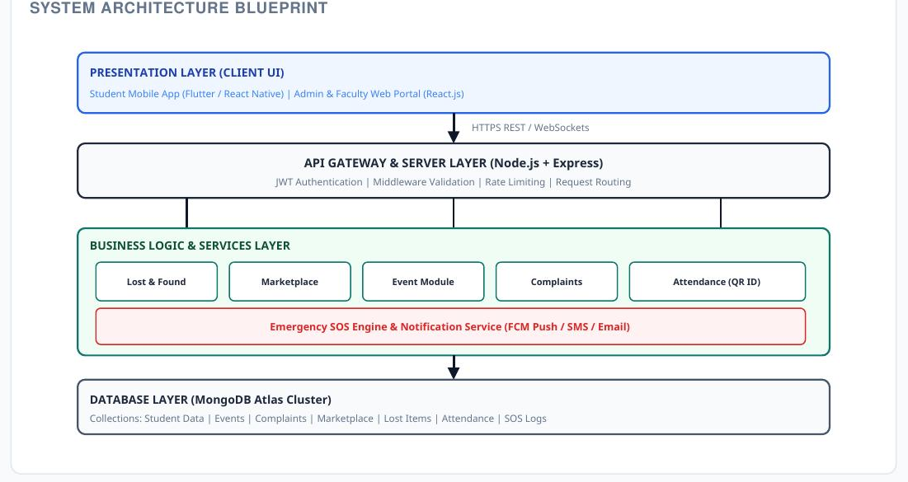

Figure 3.2 (a): High-Level Modular Architecture Blueprint

3.2 Core Modules and Functionalities
- Module 1 — Auth & User Identity: encrypted registration, institutional domain checks, session cookies, role assignment.
- Module 2 — Peer-to-Peer Marketplace: catalog publishing, multi-parameter search/filtering, request negotiation, exchange logs.
- Module 3 — Lost & Found Tracking: item reports, attribute-matching algorithm, administrative claim verification, return receipts.
- Module 4 — Facility Grievances: complaint submission, automatic authority routing, priority queues, resolution tracking.
- Module 5 — Events & Auto-Certification: event capacity management, dynamic QR pass rendering, gate scanner verification, PDF certificate creation.
- Extension Module — Emergency SOS: a real-time alert channel allowing a student to trigger an SOS with GPS coordinates, broadcast instantly to the security desk and emergency contacts, bypassing standard request queues for sub-second delivery.

3.3 User Roles Summary
Role | System Responsibilities & Module Privileges
Student | Browse marketplace, create listings, submit exchange requests, file lost/found reports, raise facility complaints, register for events, download QR passes and certificates, trigger emergency SOS.
Department Admin | Verify lost item ownership claims, resolve assigned complaints, organize events, scan gate passes, issue certificates, monitor SOS alerts.
Super Admin | Full administrative privileges; manages user roles, monitors security logs, oversees master database tables, reassigns unresolved grievances.

3.4 Functional Requirements

3.4.1 User Management & Authentication Module
Req ID | Feature | Requirement Specification
FR-101 | User Registration | Allow new users to register with Full Name, Institutional Roll No, Department, Year, Email, and Phone Number; email must match institutional format.
FR-102 | Secure Login | Authenticate using email and bcrypt-hashed password; generate an encrypted session cookie storing user_id and role_id on success.
FR-103 | Role Dashboard | Route authenticated users to a personalized dashboard showing marketplace, lost item matches, open tickets, and upcoming events.
FR-104 | Profile Self-Service | Allow updating contact details and profile image, and changing password with current-password verification.

3.4.2 Peer-to-Peer Marketplace Module
Req ID | Feature | Requirement Specification
FR-201 | Create Listing | Allow students to post items for Sale, Loan, or Giveaway with Title, Category, Price/Rate, Condition, Image, Description.
FR-202 | Marketplace Search | Dynamic keyword search and filtering by Category, Listing Type, Price Range, Condition, with pagination.
FR-203 | Exchange Request | Allow interested students to dispatch borrow/buy requests specifying duration or purchase intent.
FR-204 | Request Approval | Owners can Accept/Decline requests; accepting flags item RESERVED and notifies other requesters.
FR-205 | Transaction Ledger | Maintain an immutable history log of completed transactions, exchanges, and loans.

3.4.3 Lost and Found Module
Req ID | Feature | Requirement Specification
FR-301 | Report Missing Item | Capture Item Name, Category, Location Lost, Date/Time, Description, Unique Identifying Marks.
FR-302 | Report Discovered Item | Capture found-item reports with custody details and reference photos.
FR-303 | Algorithmic Match | Evaluate keyword/metadata overlap between open LOST and FOUND items and surface probable matches to admins.
FR-304 | Admin Verification | Department Admins evaluate ownership proof and Approve/Reject claims.
FR-305 | Return Receipt | On approval, log the handover, mark item RETURNED, and archive the ticket.

3.4.4 Grievance Redressal Module
Req ID | Feature | Requirement Specification
FR-401 | File Complaint | Report facility issues with Title, Category (IT, Maintenance, Sanitation, Library), Location, Urgency, Description, Photo.
FR-402 | Ticket Generation | Auto-generate a unique tracking code (e.g. CMP-2026-1042) and set initial status SUBMITTED.
FR-403 | Authority Routing | Automatically route new tickets to the concerned department authority based on category.
FR-404 | Lifecycle Tracking | Track progress: SUBMITTED → UNDER_REVIEW → IN_PROGRESS → RESOLVED → CLOSED.
FR-405 | User Feedback | On resolution, prompt a 1–5 star rating and remarks before closing the ticket.

3.4.5 Events & Auto-Certification Module
Req ID | Feature | Requirement Specification
FR-501 | Publish Event | Create events with Title, Department, Description, Venue, Date/Time, Seat Capacity, Certificate Eligibility flag.
FR-502 | Event Registration | Enable registration while seats remain, decrementing counters in real time.
FR-503 | Dynamic QR Pass | Generate a unique QR pass containing an encrypted validation string: SHA256(reg_id + user_id + secret).
FR-504 | Gate Pass Scanner | Web camera scanner for organizers to validate entry QR codes, preventing duplicate entry.
FR-505 | PDF Certificate Engine | Automatically compile customized PDF certificates for users marked ATTENDED after event completion.

3.5 Database Design (3NF Schema)
Data persistence for the core modules is handled by a relational MySQL database designed in Third Normal Form (3NF).
Table | Key Fields
USER | user_id (PK), full_name, roll_number (unique), email (unique), password_hash, role_id (FK → ROLE)
MARKET_ITEM | item_id (PK), owner_id (FK → USER), title, listing_type (BORROW/BUY/SELL), price, status (AVAILABLE/RESERVED/COMPLETED)
COMPLAINT | complaint_id (PK), ticket_code (unique), user_id (FK → USER), category, urgency, status (SUBMITTED/IN_PROGRESS/RESOLVED/CLOSED)
EVENT_REGISTRATION | registration_id (PK), event_id (FK → EVENT), user_id (FK → USER), qr_code_hash (unique), attendance_status (REGISTERED/ATTENDED/ABSENT)

For the emergency SOS extension, an SOS_LOGS collection (latitude, longitude, status, studentId FK) is maintained in a MongoDB Atlas cluster to support the high write-throughput, real-time nature of that feature, while the core relational schema above remains the system of record for all other modules.
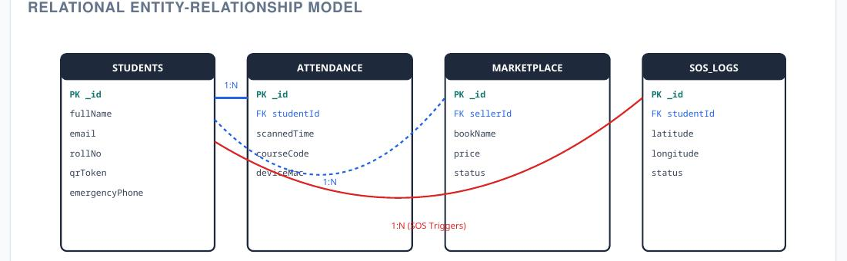

Figure 3.6: Entity Relationship (ER) Diagram — CampusCare

3.6 User Interface & Screen Specifications
- Clean visual hierarchy: card-based layout with top navbar and responsive sidebars.
- Role-aware workspaces: dashboards adapt action controls based on role.
- Semantic badging: colour-coded status badges (green = active/resolved, amber = pending, red = high urgency).
- Fully responsive: tested across desktop, tablet, and smartphone widths.
Page | Title | Access | Purpose
P01 | Login Screen | Unauthenticated | Authenticate users, issue session, route to role dashboard.
P03 | Main Dashboard | All Roles | Role-specific overview with recent activity and metric cards.
P04 | Marketplace Grid | All Roles | Search, filter, and browse listed items.
P06 | Lost & Found Board | All Roles | Browse and report lost/found belongings.
P08 | Grievance Portal | Student | File facility issues with location, priority, and photo proof.
P09 | Admin Grievance Desk | Dept Admin, Super Admin | Manage complaint queues and post resolution notes.
P10 | Events Hub | All Roles | View events, register seats, view QR passes.
P11 | Gate Scanner View | Dept Admin, Staff | Webcam interface to scan QR passes at event entry.

3.7 Technology Stack Matrix
Tier | Technology Choice | Architectural Justification
Web Frontend | HTML5 / CSS3 / JavaScript / Bootstrap 5 | Responsive, framework-light UI suited to a single web portal.
Mobile-Ready Extension | Flutter / React Native (optional) | Cross-platform compatibility with native GPS/camera access for QR scanning and SOS location capture.
Backend Engine | Node.js with Express.js | Event-driven, asynchronous framework suited to REST APIs and real-time SOS broadcasting.
Primary Database | MySQL (3NF Relational Schema) | Structured, indexed relational data management for core campus modules.
Extension Data Store | MongoDB Atlas (optional) | Flexible document storage for high-throughput, schema-light data such as SOS logs.
Notifications | Firebase Cloud Messaging (FCM) & Twilio | Multi-channel real-time alert delivery (push, SMS, email) for tickets, passes, and SOS.

3.8 System Workflow
A representative high-priority workflow — the Emergency SOS trigger — illustrates how the modular architecture handles time-critical events:
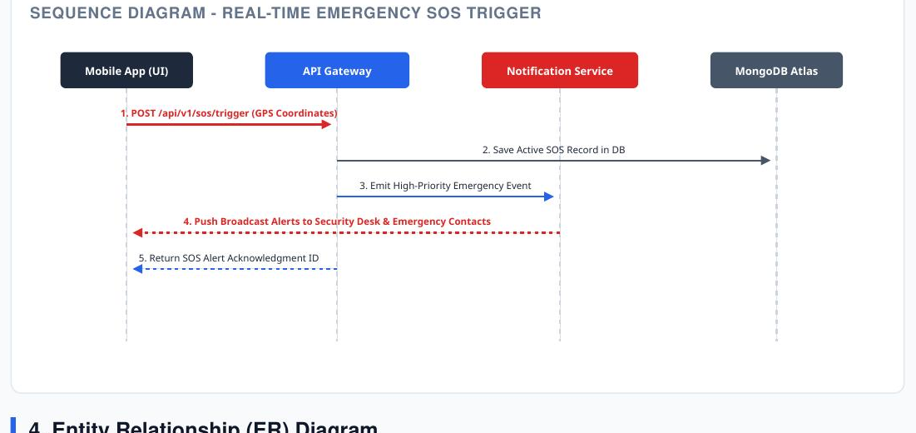

Figure 3.5: Sequence Diagram — Emergency SOS Trigger Flow
- 1. The mobile/web client posts GPS coordinates to /api/v1/sos/trigger.
- 2. The API gateway saves an active SOS record to the database.
- 3. A high-priority emergency event is emitted to the Notification Service.
- 4. Push broadcast alerts are sent to the security desk and emergency contacts.
- 5. An SOS alert acknowledgment ID is returned to the client.

3.9 Security and Data Protection Measures
- Passwords hashed using bcrypt (work factor 10); plaintext storage prohibited.
- All communications enforce HTTPS/TLS 1.2 or higher.
- Session cookies set HttpOnly, Secure, and SameSite=Strict, expiring after 30 minutes of inactivity.
- Server-side RBAC validates every API call and controller endpoint.
- JWT/OAuth-based identity verification for API requests, with bounded token expiration windows.
- Time-sensitive, dynamically regenerating QR attendance tokens to prevent proxy scanning.
- Rate limiting and payload sanitization to throttle brute-force attempts and prevent injection attacks.
- Emergency SOS events bypass standard rate-limit queues for sub-second notification processing.

3.10 Non-Functional Requirements
Category | Requirement
Performance | Standard page loads within 2.0s; indexed queries respond under 500ms; supports 100+ concurrent sessions; QR validation under 1.5s.
Reliability | 99.5% uptime target during academic terms; daily automated backups retained for 30 days.
Usability | New users can complete core tasks after a brief 5-minute orientation, following modern web standards.

3.11 Future Enhancements (Roadmap)
- UPI payment gateway integration for automated micro-payments on marketplace transactions.
- AI computer-vision matcher for automated image matching between lost and found item photos.
- SMS and WhatsApp notifications for real-time ticket resolution and pass confirmations.
- Native Android/iOS builds for wider accessibility.
The Campus Care system can be further improved in the future by adding advanced features and technologies to make campus management more efficient and user-friendly. The planned enhancements include:
- Mobile Application: Develop dedicated Android and iOS applications so that students and staff can access Campus Care easily from their mobile devices.
- Real-Time Notifications: Introduce instant notifications through email, SMS, or push notifications whenever a complaint is submitted, updated, or resolved.
- AI-Based Complaint Classification: Use Artificial Intelligence to automatically identify and categorize complaints and forward them to the appropriate department.
- Location-Based Reporting: Allow users to attach their current location or select a specific campus area while reporting an issue, making it easier for authorities to locate and resolve problems.
- Image and Video Upload: Enable users to attach photos or videos as evidence when submitting complaints.
- Analytics and Reports: Provide dashboards and graphical reports to help administrators analyze complaints, identify frequently occurring issues, and improve campus services.
- Emergency Support: Add an emergency assistance feature that allows users to quickly contact campus security, medical services, or other emergency departments.
- Feedback and Rating System: Allow users to provide feedback and rate the quality and speed of the service received after an issue has been resolved.
- Multilingual Support: Add multiple language options to make the system accessible to a wider range of students and staff.
- Integration with Smart Campus Systems: In the future, Campus Care can be integrated with smart campus technologies such as IoT sensors, automated maintenance systems, and smart security systems.
Overall, these enhancements will help Campus Care evolve into a comprehensive smart-campus platform that improves communication, safety, service quality, and the overall campus experience.

3.12 Diagrams Representing the System
The following diagrams model the structure and behaviour of CampusCare using standard UML and architectural notations.
Diagrams Representing the System
The Campus Care system can be represented using different diagrams to clearly explain its structure, functionality, and interaction between users and the system. These diagrams help in understanding the overall working of the proposed system.
1. Use Case Diagram
The Use Case Diagram represents the interaction between the users and the Campus Care system. The main actors are Students/Staff and Administrator. Students or staff can register, log in, submit complaints, upload supporting information, track complaint status, and provide feedback. The administrator can manage users, view complaints, assign issues to departments, update complaint status, and generate reports.
2. Data Flow Diagram (DFD)
The Data Flow Diagram illustrates how information moves through the Campus Care system. Users submit complaints and requests through the application. The system stores the information in the database and sends it to the appropriate department or administrator. The status of the complaint is updated and communicated back to the user.
3. Entity Relationship Diagram (ER Diagram)
The ER Diagram represents the database structure of Campus Care. Important entities may include User, Complaint, Department, Administrator, Feedback, and Notification. These entities are connected through relationships that help organize and manage system data efficiently.
4. Activity Diagram
The Activity Diagram shows the step-by-step process of reporting and resolving a campus issue. The process generally starts with user login, followed by complaint submission, verification, assignment to the concerned department, issue resolution, status update, and user feedback.
5. System Architecture Diagram
The System Architecture Diagram represents the overall technical structure of Campus Care. It can consist of the User Interface, Application/Backend Server, and Database. Users interact with the application through a web browser or mobile device, while the backend processes requests and stores information securely in the database.
6. Sequence Diagram
The Sequence Diagram shows the sequence of communication between the user, Campus Care application, administrator, and database. It explains how a complaint is submitted, stored, processed, assigned, updated, and finally marked as resolved.
These diagrams provide a clear visual representation of the Campus Care system and make it easier to understand its functionality, data flow, database relationships, and overall architecture.

3.12.1 Use Case Diagram
The Use Case Diagram illustrates the system boundary for CampusCare, capturing interactions between the primary actors (Student and Admin/Staff) and the core system modules, including the emergency SOS extension.
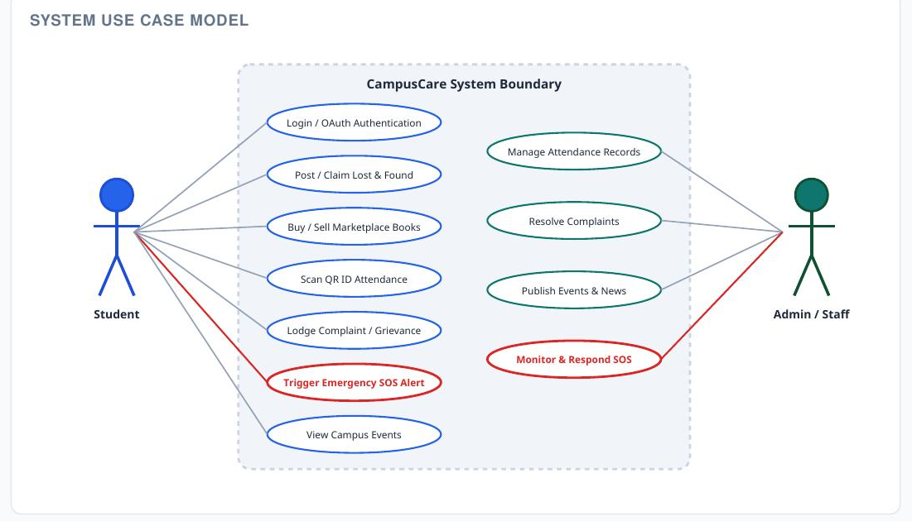

Figure 3.3: Use Case Diagram — CampusCare

3.12.2 Class Diagram
The domain class diagram shows the core entities — Student, AttendanceRecord, SOSAlert, LostAndFoundItem, MarketplaceListing, and Complaint — along with their key attributes and methods.
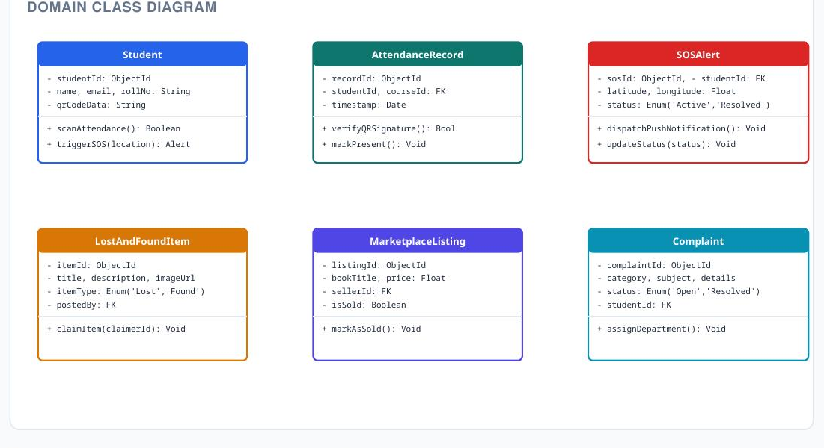

Figure 3.4: Domain Class Diagram — CampusCare

3.12.3 Sequence Diagram

See Figure 3.5 in Section 3.8 for the Emergency SOS sequence diagram.

4. EXPECTED RESULTS AND DISCUSSION
CampusCare, at the current stage, is documented as a complete Software Requirements Specification and architecture design — the functional requirements, database schema, UI inventory, and security model above are the design baseline against which implementation and testing will be carried out. This section discusses the anticipated outcomes once that design is implemented, rather than reporting results from a completed build.
EXPECTED RESULTS AND DISCUSSION
The Campus Care system is expected to provide an efficient and user-friendly platform for managing campus-related issues and improving communication between students, staff, and the administration.
Expected Results
- Easy Complaint Registration: Students and staff will be able to report campus-related issues quickly through the system.
- Faster Issue Resolution: Complaints can be automatically recorded and forwarded to the appropriate department, reducing delays in resolving problems.
- Complaint Tracking: Users will be able to check the status of their complaints and know whether they are pending, in progress, or resolved.
- Improved Communication: The system will provide a better communication channel between users and campus authorities.
- Centralized Data Management: All complaints, user details, updates, and feedback will be stored in a centralized database for easy management.
- Increased Transparency: Users can track the progress of their complaints, which improves transparency and accountability.
- Better Campus Environment: Timely reporting and resolution of issues related to cleanliness, maintenance, safety, and facilities will contribute to a cleaner, safer, and more comfortable campus.

Discussion
The proposed Campus Care system can reduce the dependence on traditional manual methods of reporting campus problems. By digitizing the complaint management process, administrators can organize, prioritize, and monitor issues more effectively. The system also allows users to participate actively in improving campus facilities.
The expected implementation of features such as notifications, complaint tracking, feedback, and administrative monitoring can improve the overall efficiency of campus services. In the future, advanced technologies such as Artificial Intelligence, location-based reporting, and data analytics can further enhance the system.
Overall, Campus Care is expected to provide a reliable and transparent solution for campus issue management while improving student satisfaction and administrative efficiency.

4.1 Anticipated Outcomes
- A single RBAC-governed portal replacing paper registers, WhatsApp groups, and notice boards for four campus service domains.
- Traceable, tracked-code grievance handling with defined lifecycle states and authority routing.
- Reduced manual effort in event operations through automated QR passes and PDF certificate generation.
- A documented basis for QA to derive unit, integration, and user-acceptance test cases directly from the FR tables in Section 3.4.
The Campus Care system is expected to produce the following outcomes:
- Efficient Issue Reporting: Students and staff will be able to report campus-related problems easily and conveniently.
- Quick Resolution of Complaints: Reported issues can be assigned to the concerned department, helping reduce response and resolution time.
- Improved Transparency: Users will be able to track the progress and current status of their complaints.
- Better Communication: The system will improve communication between students, staff, and campus administrators.
- Centralized Complaint Management: All complaints and related information will be maintained in one organized system, making it easier for administrators to manage them.
- Improved Campus Facilities: Regular reporting and timely resolution of issues can help improve cleanliness, maintenance, safety, and other campus facilities.
- Enhanced User Satisfaction: A simple and responsive complaint management process is expected to improve the overall experience and satisfaction of students and staff.
- Reduced Manual Work: Digital complaint registration and tracking will reduce paperwork and administrative effort.
- Data-Driven Management: Collected complaint data can help administrators identify common problems and make better decisions for campus improvement.
- A Safer and Supportive Campus: The overall outcome will be a more organized, clean, safe, and student-friendly campus environment.

4.2 Discussion
The 3NF relational schema keeps the core modules consistent and query-efficient, while the optional MongoDB extension isolates the one feature (SOS logging) that benefits most from a flexible, high-throughput write path — avoiding the complexity of migrating the entire system to a document store just for one feature.
The main implementation risk is coordinating two data stores (MySQL for the core, MongoDB for SOS) if the extension module is built; this can be mitigated by keeping the SOS module's read/write path fully isolated from the relational core, as shown in the sequence diagram in Section 3.8.

5. CONCLUSION AND FUTURE SCOPE

5.1 Conclusion
CampusCare consolidates four fragmented areas of everyday campus administration — peer-to-peer exchange, lost & found, facility grievances, and event management — into a single RBAC-governed web application, backed by a 3NF relational schema and a documented security model (bcrypt hashing, HTTPS/TLS, HttpOnly/Secure session cookies, and server-side RBAC on every endpoint). The specification additionally defines an optional real-time emergency SOS extension, giving the platform a path toward campus-safety functionality without disrupting the core modules.
Campus Care is an initiative designed to create a safer, healthier, and more supportive environment for students and staff. By addressing campus-related concerns efficiently and promoting awareness, communication, and well-being, it helps build a positive campus community. With active participation from students, faculty, and administration, Campus Care can contribute to a more secure, inclusive, and comfortable educational experience for everyone.
The specification additionally defines an optional real-time emergency SOS extension, giving the platform a path toward campus-safety functionality without disrupting the core modules.

5.2 Future Scope
- AI-driven, personalized recommendations for marketplace listings and lost/found image matching.
- Native mobile applications (Flutter/React Native) built on the same API gateway.
- Real-time booking and scheduling extensions for event registration.
- Payment gateway integration (UPI and card-based) for marketplace transactions.
- Expanded multilingual support for a broader campus user base.

6. REFERENCES
- IEEE Std 830-1998: IEEE Recommended Practice for Software Requirements Specifications.
- ISO/IEC 25010:2011: Systems and Software Engineering — Systems and Software Quality Requirements and Evaluation (SQuaRE).
- OWASP Foundation, OWASP Top 10 Application Security Risks, available: https://owasp.org/www-project-top-ten/.
- Node.js Documentation, available: https://nodejs.org/en/docs/.
- Express.js Documentation, available: https://expressjs.com/.
- MySQL Reference Manual, available: https://dev.mysql.com/doc/.
- MongoDB Atlas Documentation, available: https://www.mongodb.com/docs/atlas/.
- CampusCare Original Project Proposal Document — Vedant Pomendkar (Roll No. 2407106).

7. APPENDIX: API ENDPOINT INDEX
Method | API Route | Action Performed
POST | /api/v1/auth/login | Authenticate user and generate encrypted session token.
GET | /api/v1/marketplace/items | Query marketplace catalog with category and price filters.
POST | /api/v1/lost-found/claim | Submit ownership verification proof for a found item.
POST | /api/v1/complaints | File a new facility grievance ticket.
POST | /api/v1/events/verify-pass | Validate scanned QR pass token at event entry door.
POST | /api/v1/sos/trigger | Trigger a real-time emergency SOS alert with GPS coordinates.
Document Notice: This report presents CampusCare at the requirements-and-architecture design stage; the UI page inventory (Section 3.6) and API index above define the build target for the implementation phase. No output screenshots are included, as the platform has not yet been implemented against this specification.

Outputs:

Plagarism:

